**ORMAP ARROW TOOL CONVERSION REQUEST DRAFT**

**Polk County (1/27/2021)**

**Inputs:** ORMAP Arrow Tool Addin Source Code (operates in ArcMap)

**Outputs**: ORMAP Arrow Tool (ArcGIS Pro SDK for .NET / MicrosSoft Visual Studio C++). Functioning Addin and Source Code.

**Overview**: The Arrow Toolbar was developed by Oregon Department of Revenue several years ago. It operates as an Addin in the ArcMap environment. This tool needs to be converted to successfully function as an AddIn in the ArcPro Environment.

The application consist of a tool bar. The user first selects an editing template and then used the tool bar to add and modify features.

**Functional Description**:

Initial State: User is capable of editing a line feature class (cartographic lines, reference lines, etc) and has selected a specific line template (see below). There are several different templates for line arrows (lines 61,100, 120-162), a land hook (linetype 101) . Road Tics are in another feature class. The tool should operate independently of line template is selected as different counties will have different feature classes and templates for managing their maps.

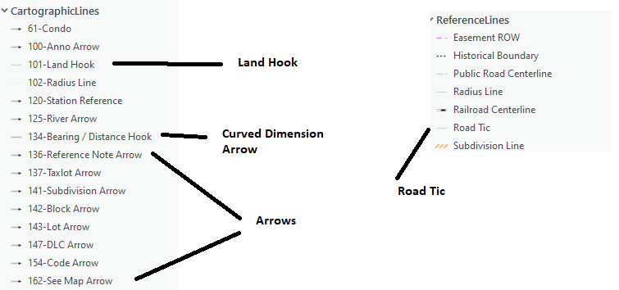

Tool Bar:

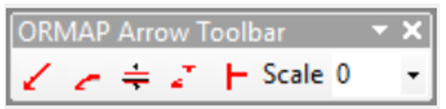

|  |  |  |  |  |
| --- | --- | --- | --- | --- |
| **Tool** | **Consensus Frequency** | **Situations where the tool is used:**  **Required for tools marked "Every few months", "About once a year", "Less than annually"**  **Insert screen caps if helpful** | **What is missing or could be improved?**  **Insert screen caps if helpful** | **Other questions, or your comments**  **Insert screen caps if helpful** |
| Place a single arrow | At least once a month | Right-click functionality:    Changing between Leader/Zigzag/Freeform  Switching arrowhead direction | Consensus: required tool. Saves time and ensures consistency. SCALE important especially along edge of map |  |
| Place a pair of curved dimension arrows | At least once a month | Right-click functionality:    Increase/decrease spacing/angle between arrows  Switching arrowhead direction  Changing scales | Consensus: required tool. Saves time and ensures consistency. SCALE important especially along edge of map |  |
| Place opposed straight arrows | At least once a month | Right-click functionality:    Increase/decrease spacing/length  Flip arrow direction  Flip arrowhead direction  Unlock/Lock angle  Changing scales | Consensus: required tool. Saves time and ensures consistency. SCALE important especially along edge of map |  |
| Place a land hook | At least once a month | Right-click functionality:    Increase/decrease spacing/angle between arrows  Flipping arrow end direction 180deg  Changing scales | Consensus: required tool. Saves time and ensures consistency. SCALE important especially along edge of map |  |
| Place a road tic | At least once a month | Right-click functionality:    Changing scales | Consensus: required tool. Saves time and ensures consistency. SCALE important especially along edge of map |  |
| Set the reference scale | At least once a month | Crashing issue, likely caused by ArcMap due to teleworking. Fixed with remote connecting to on-site tower hardwaired into network. |  | Consensus: assuming tool is stable, very useful |